Task 3 | Importing Python modules and packages in python programming
- Given a string and a number k, find the k-th non-repeating character in the string. Consider a input string with set of characters. How to find the character by only doing only one traversal of input string?
INPUT
First line of input contains a string and second line contains the value k.
OUTPUT
For each input string, Print the kth non repeating character
CONSTRAINTS
1 ≤ K ≤ 109
Sample Input and Output:
Input : str = pythonprogramming, k = 3
Output : h
First non-repeating character is y,
second is t and third is h.
Input : str = pythonprogramming, k = 4
Output : a
Input : str = pythonprogramming, k = 6
Output : Less than k non-repeating
characters in input.
Program:
# Function to find k'th non repeating character
# in string
from collections import OrderedDict
def kthRepeating(input,k):
# OrderedDict returns a dictionary data structure having characters of input
# string as keys in the same order they were inserted and 0 as their default value
dict=OrderedDict.fromkeys(input,0)
# now traverse input string to calculate frequency of each character
for ch in input:
dict[ch]+=1
# now extract list of all keys whose value is 1 from dict Ordered Dictionary
nonRepeatDict = [key for (key,value) in dict.items() if value==1]
# now return (k-1)th character from above list
if len(nonRepeatDict) < k:
return 'Less than k non-repeating characters in input.'
else:
return nonRepeatDict[k-1]
# Driver function
if __name__ == "__main__":
inp = str(input())
k = int(input())
print (kthRepeating(inp, k))

output:
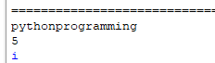
- It's a holiday season for all school students around the world! Unfortunately, Mahamba is busy preparing for International Olympiad in Informatics, which will be held in Tehran, Iran. He wants to wrie a program to Find the Sum of Cosine Series
Sample Input and Output:
First Line : Value of x in degrees
Second Line :Number of terms
Output:
Print the Sum of Cosine Series
TEST CASE 1
INPUT
65
10
OUTPUT
0.42

Program:

import math
def cosine(x,n):
cosx = 1
sign = -1
for i in range(2, n, 2):
pi=22/7
y=x*(pi/180)
cosx = cosx + (sign*(y**i))/math.factorial(i)
sign = -sign
return cosx
x=int(input())
n=int(input())
print(round(cosine(x,n),2))

Output:
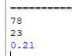
- Create a modular Python application to analyze student performance data. The program must be split into separate modules to follow good programming practices:
- Module 1 will handle data loading from a CSV file.
- Module 2 will handle statistical analysis of the data.
- The main program will import these modules, perform calculations, and display the results in a formatted table.
Sample output:
Subject Mean Standard Deviation Mode
0 Math 86.000000 7.071068 85
1 Science 82.600000 10.200000 78
2 English 85.400000 8.089483 92
students.csv
Name,Age,Math,Science,English
Alice,20,85,78,92
Bob,21,90,88,84
Charlie,20,72,65,70
David,22,95,92,96
Eva,21,88,90,85

dataloader.py
import pandas as pd
def load_data():
df = pd.read_csv("students.csv")
return df

statshelper.py
import numpy as np
from scipy import stats
def subject_mean(df, subject):
return np.mean(df[subject])
def subject_std(df, subject):
return np.std(df[subject])
def subject_mode(df, subject):
return stats.mode(df[subject], keepdims=True).mode[0]

main.py
# Step 1: Imports
from dataloader import load_data
from statshelper import subject_mean, subject_std, subject_mode
import pandas as pd
# Step 2: Load CSV data
df = load_data()
# Step 3: Subjects to analyze
subjects = ["Math", "Science", "English"]
# Step 4: Collect results
results = []
for subj in subjects:
mean_val = subject_mean(df, subj)
std_val = subject_std(df, subj)
mode_val = subject_mode(df, subj)
results.append([subj, mean_val, std_val, mode_val])
# Step 5: Create results table
results_df = pd.DataFrame(results, columns=["Subject", "Mean", "Standard Deviation", "Mode"])
print(results_df)

output:
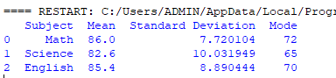

- Create a program to generate sample sales data for different products, calculate total sales for each product, identify the top-selling product, and display the total sales amount along with the data.
Sample output:
Top Selling Product: Laptop
Total Sales: ₹ 1215587
Sample Data:
Product Units _Sold Price_per_Unit Total_Sales
0 Laptop 21 4633 97293
1 Headphones 32 4876 156032
2 Mouse 26 2711 70486
3 Keyboard 14 2789 39046
4 Laptop 12 4640 55680

import pandas as pd
import numpy as np
# Create sample sales data
data = pd.DataFrame({
'Product': ['Laptop', 'Headphones', 'Mouse', 'Keyboard'] * 5,
'Units_Sold': np.random.randint(5, 50, 20),
'Price_per_Unit': np.random.randint(1000, 5000, 20)
})
# Calculate total sales for each row
data['Total_Sales'] = data['Units_Sold'] * data['Price_per_Unit']
# Find top-selling product
top_product = data.groupby('Product')['Total_Sales'].sum().idxmax()
# Calculate total sales
total_sales = data['Total_Sales'].sum()
# Show results
print("Top Selling Product:", top_product)
print("Total Sales: ₹", total_sales)
print("\nSample Data:\n", data)

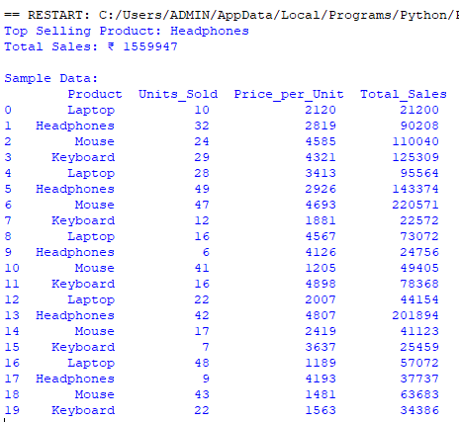

- To write a Python program using packages with modules for geometry (area, perimeter, hypotenuse) and text processing (uppercase, word count, palindrome) by organizing code into reusable components.

Algorithm
Step 1 – Create the Package Structure
- Create a folder named my_toolkit
- Inside my_toolkit, create:
- __init__.py
- geometry_utils.py
- text_utils.py
Step 2 – Implement geometry_utils.py Module
- area_circle(radius) → Returns π × radius².
- perimeter_rectangle(length, width) → Returns 2 × (length + width).
- pythagoras(a, b) → Returns √(a² + b²).
Step 3 – Implement text_utils.py Module
- to_uppercase(s) → Returns the string in uppercase.
- word_count(s) → Counts the number of words.
- is_palindrome(s) → Returns True if the string reads the same forward and backward.
Step 4 – Initialize Package with __init__.py
- Import functions from geometry_utils and text_utils so they are directly accessible from my_toolkit.
Step 5 – Create main.py Program
- Import all required functions from my_toolkit.
- Call geometry functions and display their results.
- Call text functions and display their results.
Step 6 – Execute the Program
- Run python main.py in the terminal.
- Verify that outputs match expected results.

Program
1. Folder structure:
my_toolkit/
__init__.py
geometry_utils.py
text_utils.py
main.py

my_toolkit/geometry_utils.py
import math

def area_circle(radius):
return math.pi * radius ** 2

def perimeter_rectangle(length, width):
return 2 * (length + width)

def pythagoras(a, b):
return math.sqrt(a**2 + b**2)

my_toolkit/text_utils.py
def to_uppercase(s):
return s.upper()

def word_count(s):
return len(s.split())

def is_palindrome(s):
s_clean = ''.join(s.lower().split())
return s_clean == s_clean[::-1]

my_toolkit/__init__.py
from .geometry_utils import area_circle, perimeter_rectangle, pythagoras
from .text_utils import to_uppercase, word_count, is_palindrome

main.py
from my_toolkit import area_circle, perimeter_rectangle, pythagoras
from my_toolkit import to_uppercase, word_count, is_palindrome

# Geometry functions
print("Area of circle (r=5):", round(area_circle(5), 2))
print("Perimeter of rectangle (4x6):", perimeter_rectangle(4, 6))
print("Hypotenuse (3,4):", round(pythagoras(3, 4), 2))

# Text functions
print("Uppercase:", to_uppercase("hello world"))
print("Word count:", word_count("Python is fun"))
print("Is palindrome (level):", is_palindrome("level"))

Sample Output
Area of circle (r=5): 78.54
Perimeter of rectangle (4x6): 20
Hypotenuse (3,4): 5.0
Uppercase: HELLO WORLD
Word count: 3
Is palindrome (level): True

